Name ________________________________________________________
Social Studies Study Guide
TEST: Friday August 15
For my Social Studies test, I should be able to…
- Find the country I live in and color it.
- Locate the equator line.
- Use cardinal and intermediate directions (N, S, E, W, NE, SE, SW, NW) to find continents on a map (the continents will be labeled).
- Decide which way I would fly to travel to other continents. For example, answer this question: If you are in Antarctica, which way would you travel to fly to South America?
- Use a map grid and symbols to answer questions.
- Find the area on the map that would have the warmest climate—the closer we get to the equator the warmer it gets!
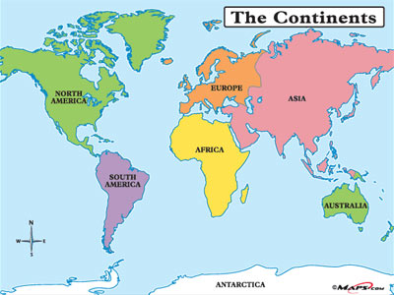
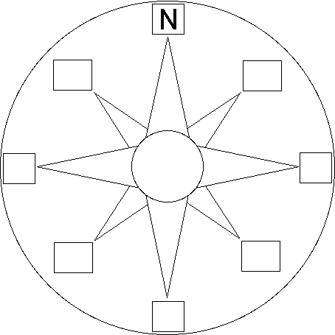
Parents: We will practice these skills in class, but extra practice at home will definitely help. Please keep this study guide in your child’s agenda. If you have any questions, call or email me. Thank you for all your support at home!

