KEEP THIS FORM INYOUR BINDER AND TURN IT IN WITH YOUR FINAL PRODUCT ON OCTOBER 30TH.

Name _______________________________
Pollution and Conservation
Chapter 8 Project—Due: October 30th
Instead of a test for chapter 8, you will choose one of the following projects to show that you understand the concept of pollution and conservation of natural resources. Use your textbook (Harcourt Science) and Galileo to research and then present the information you learned in one of the following formats:
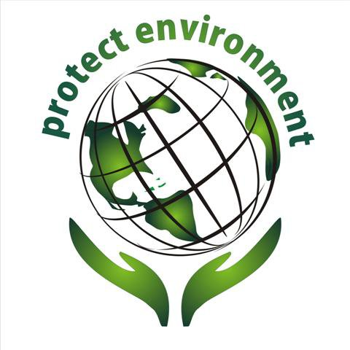
- Paper slide video—like the one we made about Paul Revere
- Discovery Education Board Builder—like the one you made about a Georgia habitat
- Poster
You must include information about:
- Natural resources: nonrenewable and renewable
- Types and examples of pollution: land, air, and water
- Examples of conservation
- What is means to reduce, reuse, and recycle resources
- How you plan to help the environment

Check off each item as you complete the task:
_____I have shown this paper to my parents. Parent’s initials ____________
_____I have chosen the following format from above: __________________
_____I have found at least one article from Galileo to help me research and show it to Mrs. Anderson (Mrs. Anderson must initial this one).
_____I listed where I found my information somewhere in my project (one source will be “Harcourt Science” and the other will be the title of the articles you found on Galileo).

