Unit 2 Study Guide: Paul Revere
Test Date: September 12
For my test, I must know that…
- Paul Revere worked for freedom from the British because he felt England sometimes treated the thirteen colonists unfairly.
- The British Army wanted to destroy the militia’s weapons
- Paul Revere warned the colonists that the British were coming.
- The Sons of Liberty agreed with Paul Revere’s political beliefs. They also wanted freedom from England.
- Liberty means freedom and independence.
- Paul Revere lived in Boston, Massachusetts.
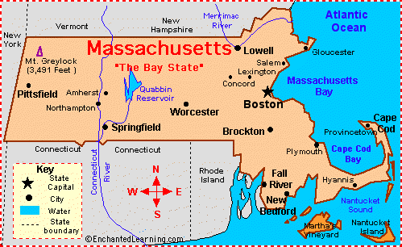
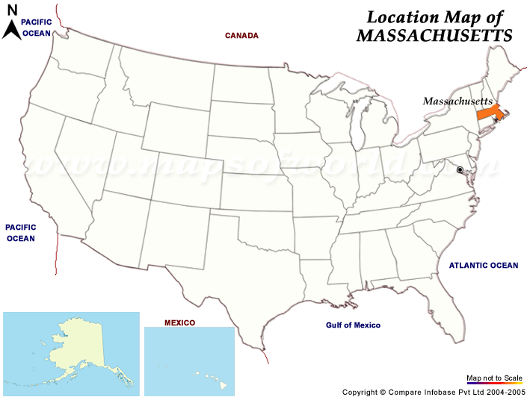
- A militia is a group of citizens who are trained for battle. The colonists formed militias to fight against the British army.
- Paul Revere was courageous because he rode his horse to warn everyone. He strongly believed in fighting for independence. Even if he were going to be arrested, he wanted to stand up for what he believed.

